A Study On Object Detection And Its Application.

Vaibhav Sharma
AIT-CSE, AIML
Chandigarh University, Punjab, India
Kashipur, Uttarakhand, India
vaibhavsharmavvs@gmail.com

Endluru Vignesh
AIT-CSE, AIML
Chandigarh University, Punjab, India
Renigunta, Andhra Pradesh, India
endluruindvignesh2002@gmail.com
Koppula Prakash
AIT-CSE, AIML
Chandigarh University, Punjab, India
Khammam, Telangana, India
prakashkoppula98@gmail.com

Maram Leela Krishna Subrahmantyam
AIT-CSE, AIML
Chandigarh University, Punjab, India
Guntur, Andhra Pradesh, India
leelakrishnasubrahmanyammaram@gmail.com

Abstract—
Keywords—Machine Learning, Object Detection, Deep Learning, Computer Vision (key words)

Introduction
Object detection is a widely known research direction in the fields of data science, artificial intelligence, machine learning and computer vision [2]. It is the building block for many more complex projects like object tracking, behavior analysis and facial recognition[2]. It is designed to locate the target object and accurately categories the object. It is an example of a supervised learning algorithm as it requires labeled data as a prerequisite to training and constructing the model. understand the underlying pattern hidden to be able to successfully yield satisfactory results on the testing data. A study performed in 2018 states that the current trends state that the fields of computer vision and artificial intelligence will see a big rise due to many industries and other sectors relying on automation including sectors like medical, defense and also other sectors such as agriculture which are making a swift change towards automation and artificial intelligence [3].
Deep Learning word has become a famous domain nowadays within computer vision mainly because of the highly successful results produced by deep learning algorithms in the fields of image classification, object detection and natural language processing [3].
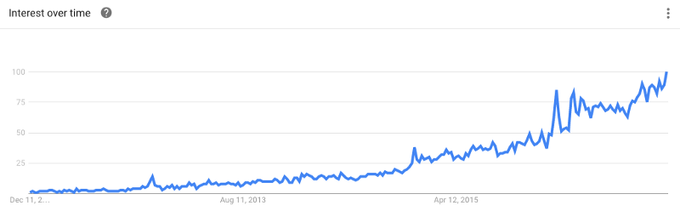
Fig.1 The rising trend of deep learning in the last decade.
Deep Neural architectures handle complex image processing and detection models better than normal shallow algorithms [3]. Deep Neural networks like CNN shows average accuracy for smaller and simpler data but represents very high accuracy on large datasets of images [5]. This shows the rising trend of deep learning used in image processing and objects detection.
In General, Object Detection techniques with deep learning are divided into two categories: direct object prediction in which we directly predict the object in the boundaries without any intermediate task in between, it means in a one stage fashion [6]. This leads to faster response but the model is not flexible for a change in tasks. Other category is of two stage detection which implements the concept of regression algorithms [6]. Both of the categories are dealt with detail in the later sections.
Applications of object detection include medical image diagnosing systems, smart video surveillance systems, Industrial hazard detection systems, Vehicle detection and monitoring system and in agriculture fields and farms etc [3].
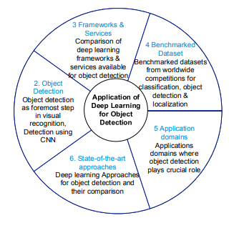
Fig.2 How Deep learning plays a vital role in Object detection and its application [3]
A couple of cases which can take the help of object detection are mentioned: Object detection can be used to look over animal farms to inform the owner of any kind of break in from other animals like wolves and dogs [11]. Another example could be in traffic detection system to differentiate between cars, two wheelers and trucks to divert the traffic accordingly [12].
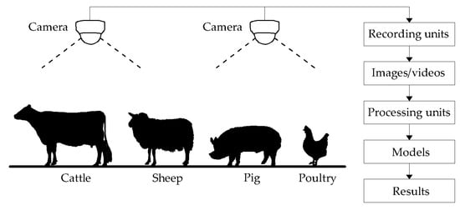
FIG.3 Animal farms implementing object detection

LITERATURE REVIEW

There are a lot of innovative and inspiring ideas for object detection models which are constructed either from a business standpoint or research programs. Some of which will be dealt with detail in this module:
S. Manjula [1] proposed a model to replace all the human labored detection systems with machine learned models. This model implies the use of background modeling to extract the object from the background and motion segmentation to track independent moving objects [7]. Moreover it makes the use of object classification to distinguish objects and behavioral analysis to predict high level description of actions. The model was successful in fulfilling the task of building a automatic detection system which can be used in place of a human powered one but the methods compared in the models were either low accuracy and low computational power or having significant accuracy but requires high computational power which can disrupt the cost side of the system from a financial point.

Jun Deng et al [2] in 2020 compared two types of target detection frameworks namely one stage and two stage detections. The Algorithms used for one stage detections were various modifications of YOLO (You only look once) which are faster and provides high performances as it make use of one stage detection. In comparison to the models used by two stage detection models like R-CNN [8] or faster R-CNN [9] and its variations have reached record breaking accuracy but are very high power consuming algorithms. Models like SSD [10] proposed by Liu were able to find a middle path with moderate speeds with less power consuming algorithms. The paper concluded that future research should reduce the dependence of data and to achieve efficient detection of small objects.

Ajeet Ram Pathak [3] introduced the frameworks and services used in research for object detection. Datasets that are reviewed and benchmarked by companies like Microsoft and Caltech are available to improve the current object detection models. Moreover Deep Learning Frameworks and services available for object detection with their respective features, Interface, softwares and which deep learning models it accompanies and licensing required are available in a tabular format to help new developers in the particular field to learn the basics of the object detection domain.

Jun Wang [6] proposed a method for bounding the spatial location and space around the target variable inside an image or a video wit the help of background subtraction, object localization and semantic segmentation. Moreover the structure and working of many known object detection algorithms are discussed and defined. Evaluation metrics such as confusion matrix and precision, recall are detailed. Furthermore, the Development and evolution of object detection technologies are discussed. Various application of object detection can be pedestrian detection to reduce accidents , facial and text detection and remote sensing object detection which is still a research direction within object detection.

Zhong-Qiu Zhao [5] introduced with the brief overview and history and prosperity of deep learning. Generic object detection different from general object detection aims to recognize existing objects fed to the machine learning models with boxes around the object. Salient object detection is the most challenging field of object detection is used to find the most dominant objects present in a image. Various applications accompany salient object detection such as image cropping, image retrieval and even in investigations to highlight clues. Facial Detection is essentially the more complex form of object detection but captures human faces and is basically the prerequisites for facial recognition, facial synthesis and facial expression analysis which are many different domains inside the image processing field.

PROPOSED WORK
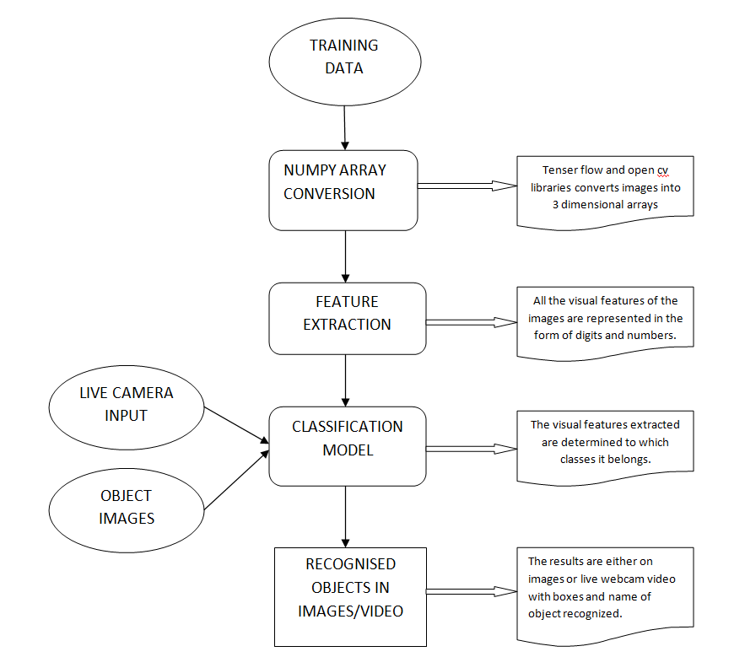
Fig.4 Schematic Representation of basic Object detection model.

- For the training data we provide the model with plenty of training images and class labels of the objects present in the images so the model can learn which object has to be classified in which label. Many open source datasets for object detection containing the class labels are provided on the web to make the task easier.

- Next is to load the model into the system many pre trained models are present online and they work well as they tend generalize well. One such model is ssd mobile net which works very well for object detection and provide faster results.

- Since the Opencv works on the principle of data flow graph we have to download the frozen inference graph for our particular model that is supported form the web. The frozen inference graph is needed to be loaded into the memory.

- Now to work with Opencv we have to convert the images into the numpy array. So we use the reshape feature of the numpy libraries to convert the complex images into arrays so it is easier to process for the Opencv.

- Next, is to provide the test input in the model to check whether our model is working well or not. We can choose any number of images and store it in a folder whose path is to be given.

- The output containing detection boxes means the boxes in which the object is enclosed is formed along with detection classes and detection scores which indicate the likelihood of matching the predicted result with actual object.

RESULTS AND DISCUSSION

Our Project mainly deals with the detection aspect of the given moving inputs either in the form of videos from existing sources otherwise in the form of live input from closed circuit television present in almost all the places with basic security requirements or web cameras from computer users. The aim of the paper include to segment the detection in different types and study on their characteristics like the required computational power etc.

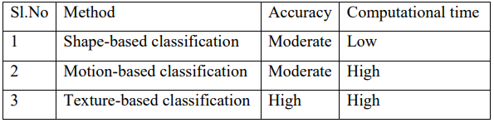
Fig 5. Different Object detection methods

The paper explains how modern day object detection systems work with the help of pre trained models and vast amount of data that can be extracted from the internet. The research paper is used to make comparisons between different types of algorithms and models used in the object detection field on the basis and grounds of accuracy, speeds and other aspects.

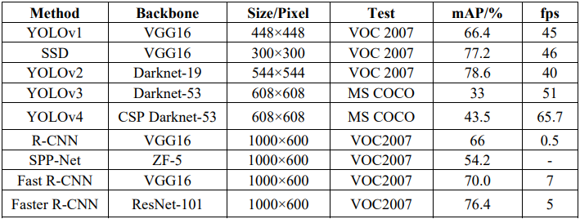
Fig 6. Comparisons of different object detection algorithms

The research paper has also gone in depth analysis of other models proposed by researchers and object detection developers around the world and listed out all the pros and cons of the same and what can be done to achieve and even improve the future scope of the project. Moreover the work-flow and brief of the algorithm used in the particular paper is also discussed.
The research paper also explains the difference between the conventional object detection models that were used earlier and how the modern day versions has replaced them and modified them to a better model. The paper also deals with how an object detection model with deep learning follows the algorithm and what are all the steps and instructions through which the whole model has to go through. This visualization is better made understood with help of images, data flow diagram and flowcharts. Our ultimate goal is to motivate researchers around the globe and readers to come up with better object detection models than shown in this research paper in the future which can completely change the biometric and facial recognition industry and aspects of the existing authentication systems in smart phones and other electronics which require some kind of authentication to unlock.

CONCLUSION

Our object detection application work on the principle of opencv which resides on the framework of deep learning. The pre-trained model used for the task is ssd-mobile net which is trained upon coco dataset which contains a total of 91 image classes and labels that the model can successfully detect with appropriate accuracy. Our project works with three function one uses images as input the other option take videos as images and detect objects in the video with the timestamp and finally one which uses the webcam and take live video from webcam as input and detect objects in front of the system. The graphical user interface used for the frontend is made with tkinter library and successfully transforms ordinary hard to navigate independent functions to an interactive easy to navigate and operate complete application with all the functionality.

RESULTS AND OUTPUTS

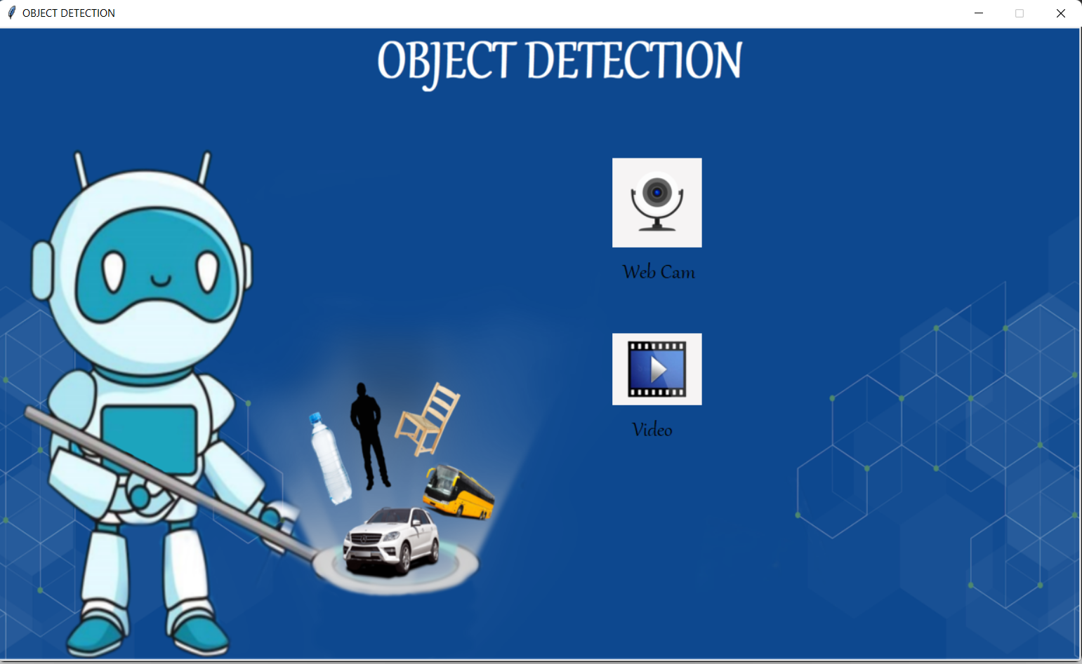

Fig 7. Main Menu consisting of graphical user interface



Fig 8. Start Stop screen for better Interaction with application.

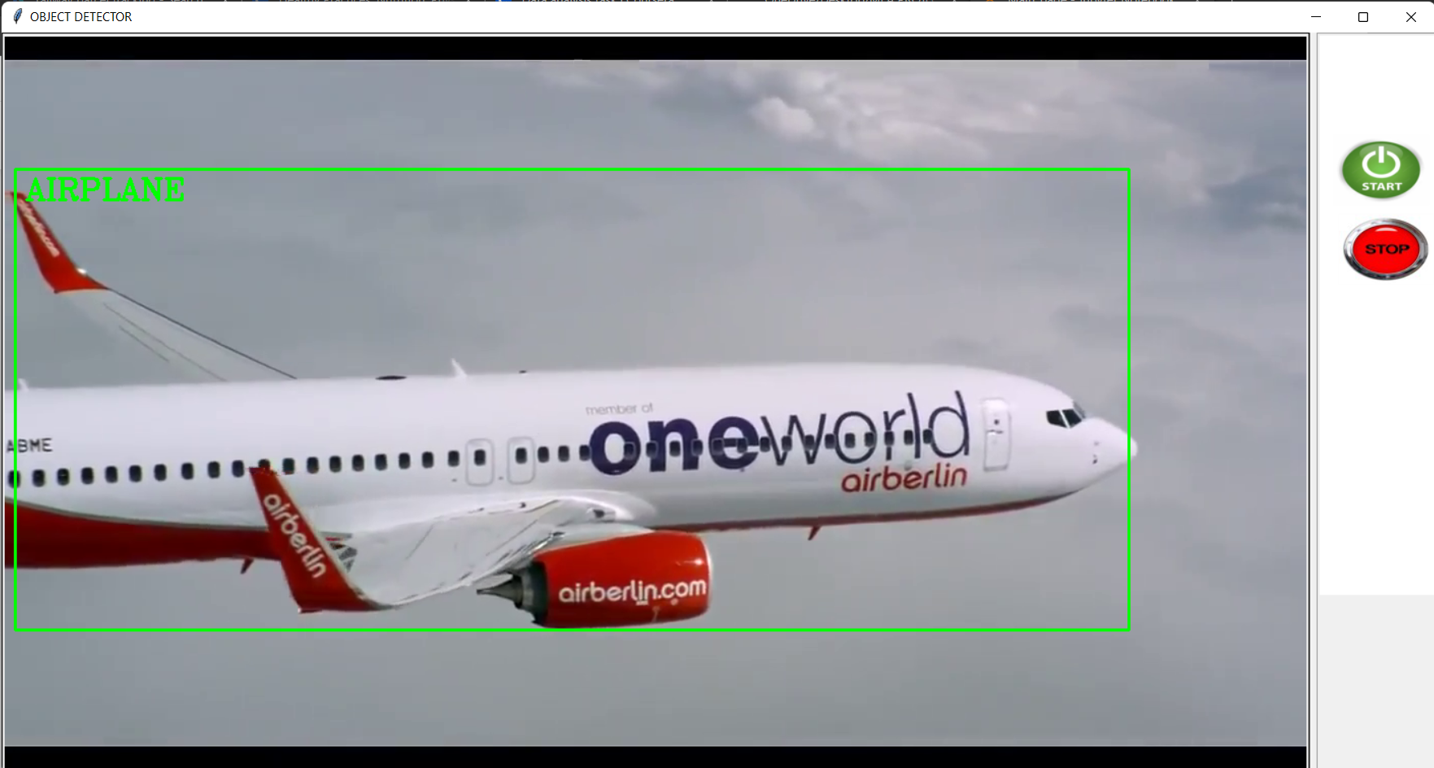
Fig 9. Object detection taking place with video as input

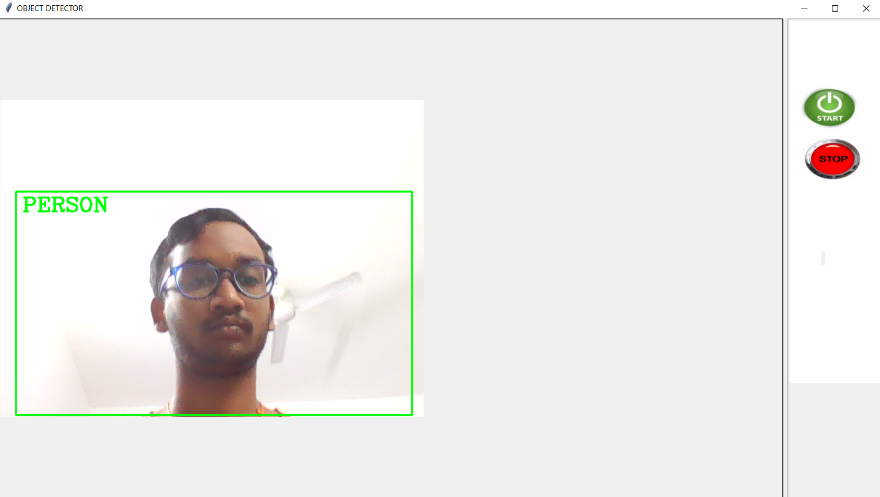
Fig10. Object Detection with Live video from webcam as an input

References

[1] Manjula S, Lakshmi Tamilselvan (2016) A study on object detection.
[2] Jun Deng, Xiaojing Xuan, Weifeng Wang, Zhao Li, Hanwen Yao, Zhiqiang Wang (2020) A review of research on object detection based on deep learning.
[3] Ajeet Ram Pathak, Manjusha Pandey, Siddharth Rautaray (2018) Applications of Deep Learning for object detection.
[4] Sunil, Gagandeep (2019) Study of object detection methods and applications on digital images.
[5] Zhong-Qiu Zhao, Shou-tao Xu, Xindong Wu (2017) Object detection with deep learning: A review.
[6] Jun Wang Tingjuan Zhang, Yong Cheng, Najla Al-Nabhan (2021) Deep Learning for Object detection: A survey.
[7] C.Stauffer and W.Grimson.Adaptive background mixture models for real-time tracking. Proceedings of IEEE Conf.Computer Vision and pattern Recognition,vol.2,1999, 246-252.
[8] Girshick, R., Donahue, J., Darrel, T.,Malik, J. Rich Feature Hierarchies for Accurate Object Detection and Semantic Segmentation. In: Computer Vision and Pattern Recognition. Columbus.2014, pp. 580-587.
[9] Ren, S.Q., He, K.M., Girshick, R., Sun, J. Faster R-CNN: towards real-time object detection with region proposal networks. In: Advances in neural information processing systems. Montreal.2016, pp. 91-99.
[10] Liu, W., Anguelov, D., Erhan, D., et al. SSD: Single Shot MultiBox Detector. European Conference on Computer Vision, 2016, pp. 21-37.
[11] Dr. Sabeenian R.S, N Deivanai (2020) Wild animals intrusion detection using deep learning techniques.
[12] Khyati Zalawadia ,Helly Shah ,Radhika Shringarure (2015) Traffic Detection and Diversion System: Case Study

